Lab 8 Automating Advanced File Management and Permissions in Linux Documentation
By Fatima Abubakar

Lab Overview
The objective of this lab was to automate administrative file management tasks using Bash scripting. Key areas of focus included conditional permission checks, recursive ownership modification, Access Control List (ACL) management, and system backups with metadata preservation.

Automating File Permissions
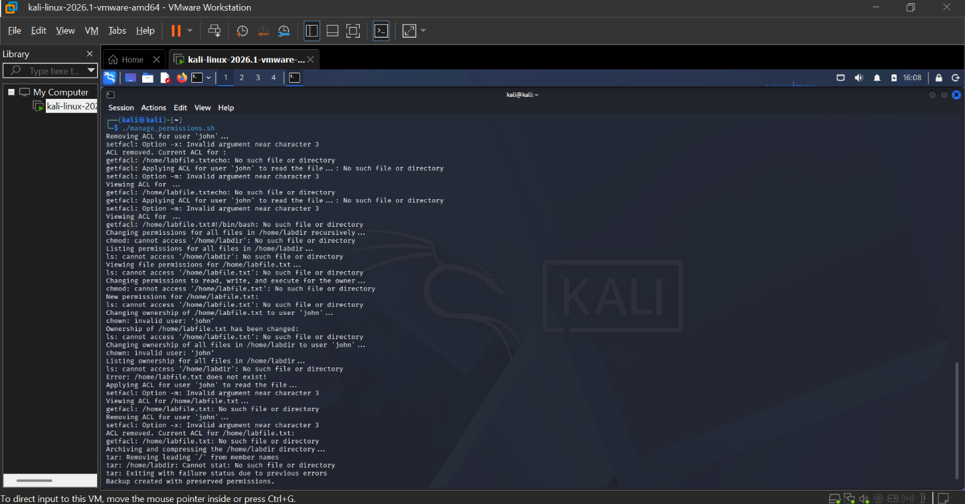

Exercise 1
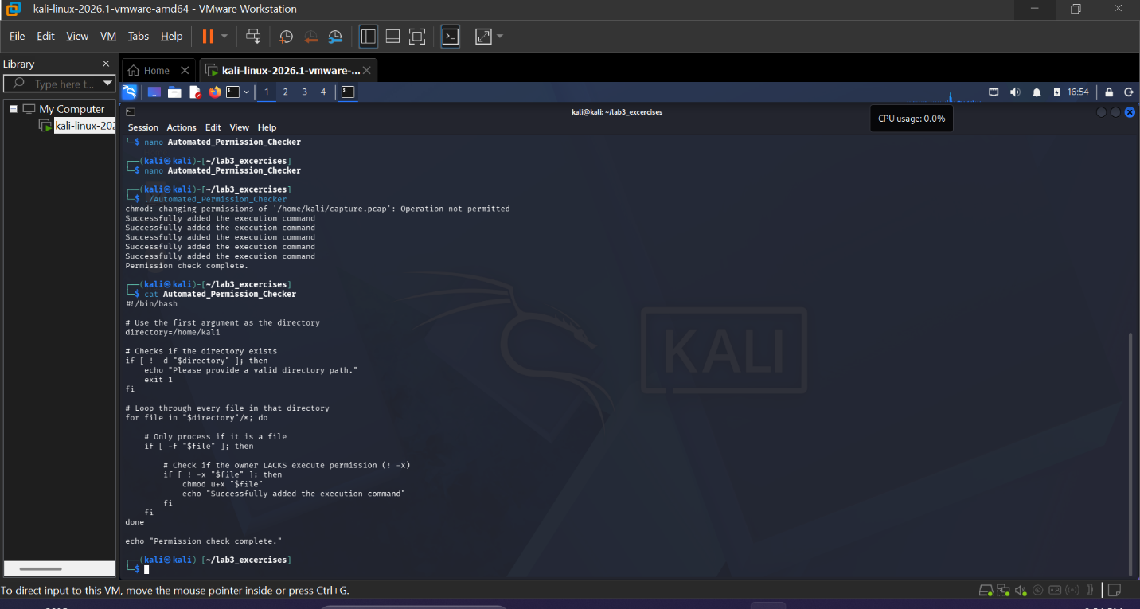
In this exercise, i ensure all files in a directory have executive permissions for the owner. Then, developed a script using a for loop to iterate through a directory and a conditional if [ ! -x ] check to identify files missing the execute bit. Finally, I used this key command chmod u+x "$file" which change adds the execution to the owner.

Exercise 2
Bulk Ownership Change
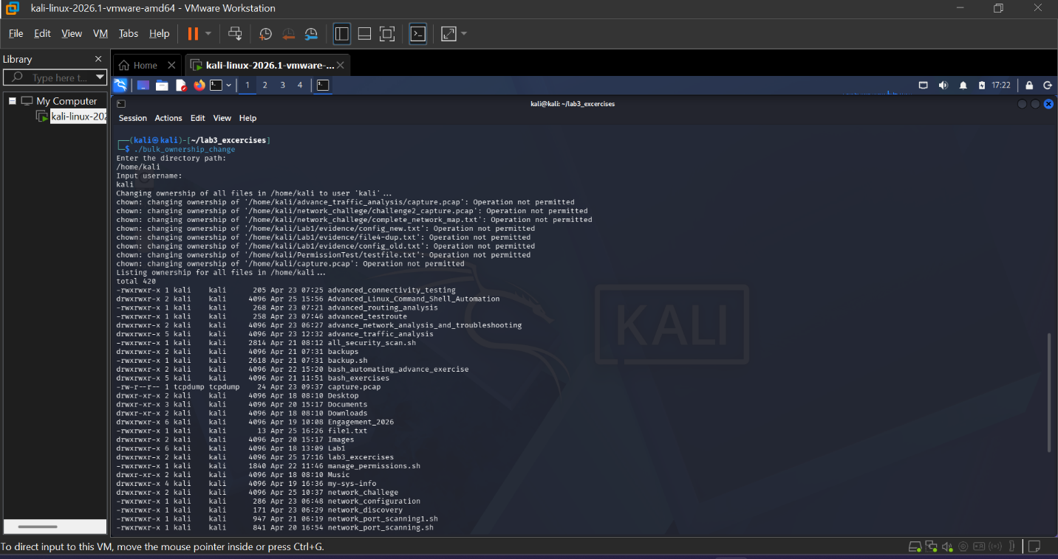

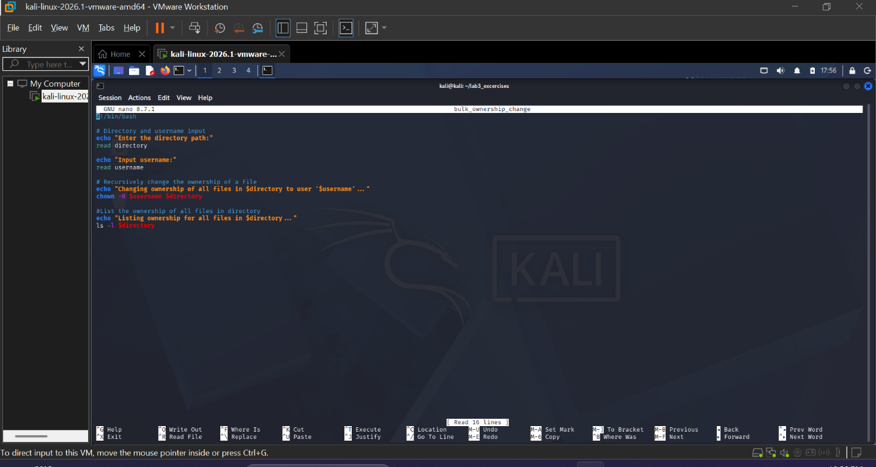
The goal of this exercise is, recursively change ownership of a directory based on user input. I then used the read command to capture the target username and directory and i applied the change globally across the directory tree. The key command for this exercise is, chown -R "$username" "$directory" which changes the ownership of the directory.

Exercise 3
Automated ACL Management
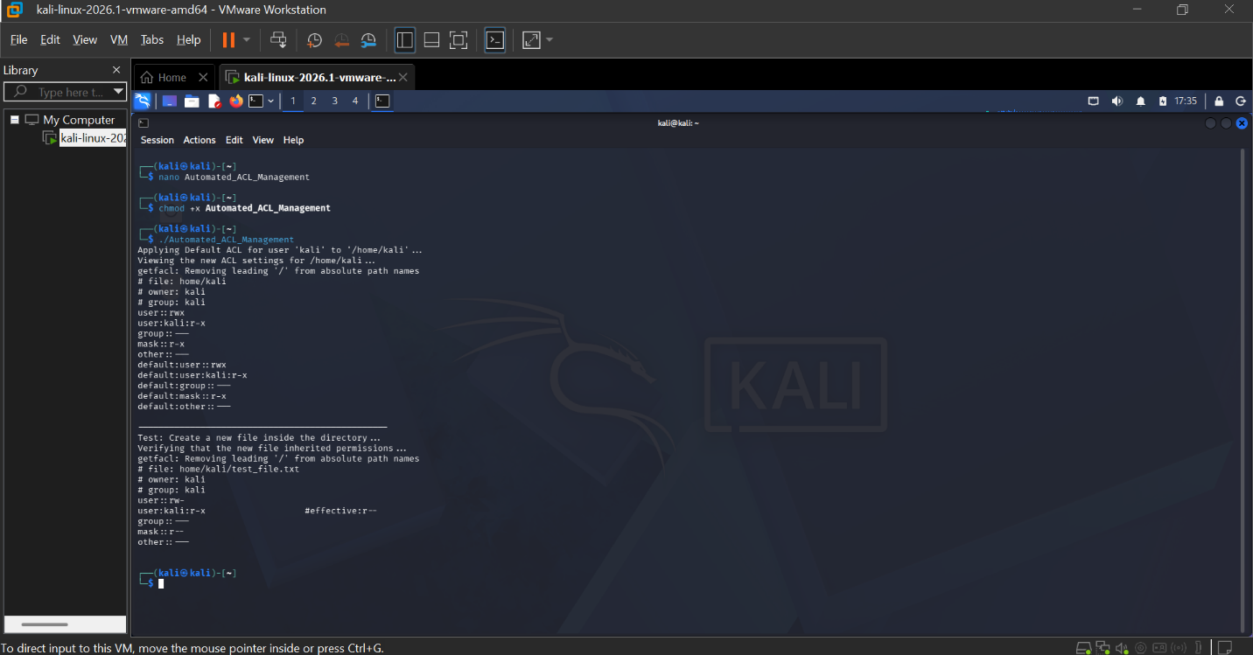

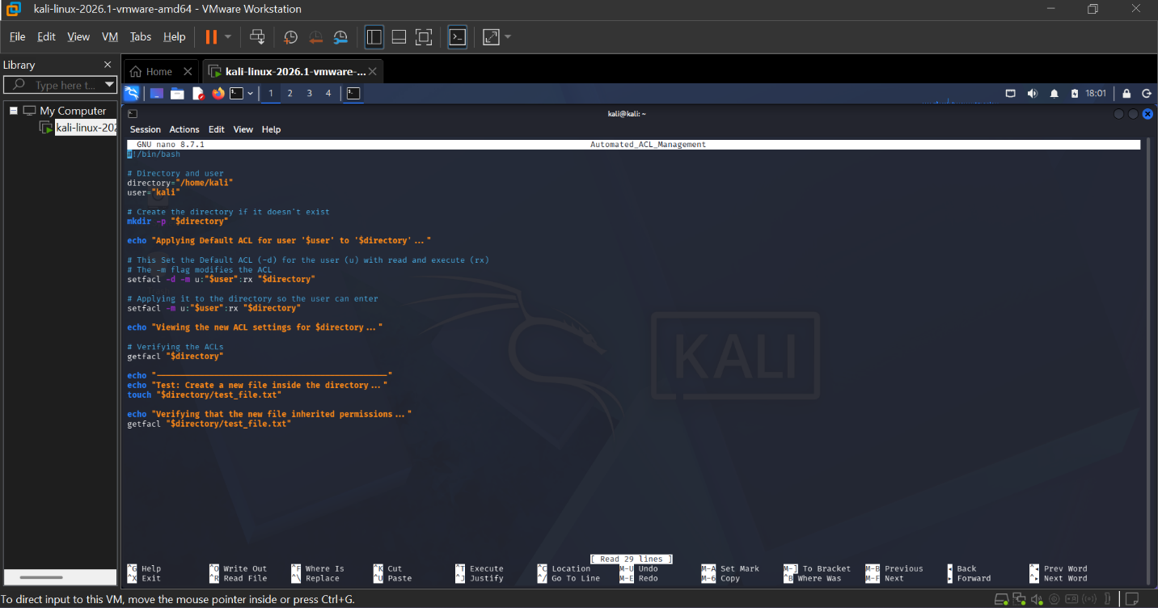

The goal of this exercise is to set persistent, default permissions for a specific user on a directory. Which Utilized the setfacl command with the -d (default) flag. This ensures that any files created in the future automatically inherit the specified permissions. And lastly, the key command for this exercise is setfacl -d -m u:"$user":rx "$directory" in which is used as Access Control Lists (ACLs) which allow us to give specific permissions to specific users without changing the main "owner" of the folder.

Exercise 4:
Scheduled Backup Script
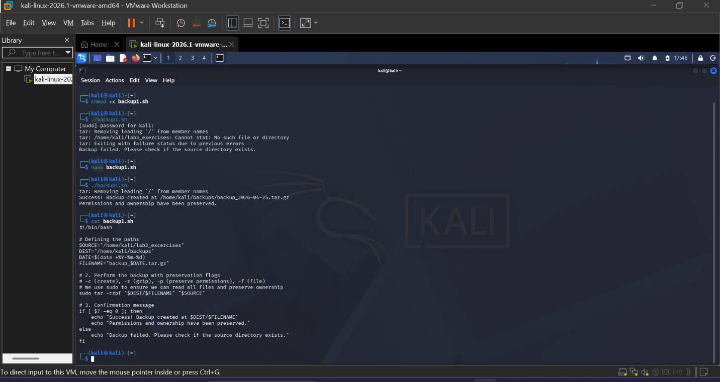
The goal of this exercise is to create daily compressed backups while preserving file attributes. Which used the tar utility with metadata preservation flags. The script generates a unique filename using the $(date +%Y-%m-%d) variable. And the key command for this exercise is tar -czpf backup_$(date +%Y-%m-%d).tar.gz /source/path in which is used to bundle files together into a single compressed archive while keeping their security settings intact.

Conclusion
This lab demonstrated how scripting reduces human error in system administration. By automating permission audits and backups, we ensure a consistent security posture and reliable data recovery processes.

